1010100
10011000
10001111100
1011100101011100
101100011101001
1011110100011010
00001010010110010
1001010101100111
1111010101000101
1101001101010011
001010010101010
1010101000110010
010101001011000
110101100011010
11010100001011
001010100110
1001010010
IP Addressing
and Subnetting

Workbook
Version 1.5

11111110
101
001
10010101
00011011
11010011
Student Name:

10000110

IP Address Classes
Class A 1 – 127 (Network 127 is reserved for loopback and internal testing)
 |  | Leading bit pattern | 0 | 00000000.00000000.00000000.00000000  Network . Host . Host . Host
Class B | 128 – 191 | Leading bit pattern | 10 | 10000000.00000000.00000000.00000000  Network . Network . Host . Host
Class C | 192 – 223 | Leading bit pattern | 110 | 11000000.00000000.00000000.00000000
Class D | 224 – 239 | Network . Network . Network . Host  (Reserved for multicast)
Class E | 240 – 255 | (Reserved for experimental, used for research)

Private Address Space
Class A 10.0.0.0 to 10.255.255.255
Class B 172.16.0.0 to 172.31.255.255
Class C 192.168.0.0 to 192.168.255.255

Default Subnet Masks

Class A | 255.0.0.0
Class B | 255.255.0.0
Class C | 255.255.255.0

Produced by: Robb Jones jonesr@careertech.net
Frederick County Career & Technology Center Cisco Networking Academy
Frederick County Public Schools Frederick, Maryland, USA

Special Thanks to Melvin Baker and Jim Dorsch for taking the time to check this workbook for errors,
and to everyone who has sent in suggestions to improve the series.

Workbooks included in the series:

IP Addressing and Subnetting Workbooks ACLs - Access Lists Workbooks
VLSM Variable-Length Subnet Mask IWorkbooks
Inside Cover

Binary To Decimal Conversion

16 32
128 | 64 | 32 | 16 | 8 | 4 | 2 | 1 | Answers Scratch Area
1 | 0 | 0 | 1 | 0 | 0 | 1 | 0 | 146 128 64
0 | 1 | 1 | 1 | 0 | 1 | 1 | 1 119 2 16
1 | 1 | 1 | 1 | 1 | 1 | 1 | 1 |  |  | 146 4  2
1 | 1 | 0 | 0 | 0 | 1 | 0 | 1 |  |  | 119
1 | 1 | 1 | 1 | 0 | 1 | 1 | 0
0 | 0 | 0 | 1 | 0 | 0 | 1 | 1
1 | 0 | 0 | 0 | 0 | 0 | 0 | 1
0 | 0 | 1 | 1 | 0 | 0 | 0 | 1
0 | 1 | 1 | 1 | 1 | 0 | 0 | 0
1 | 1 | 1 | 1 | 0 | 0 | 0 | 0
0 | 0 | 1 | 1 | 1 | 0 | 1 | 1
0 | 0 | 0 | 0 | 0 | 1 | 1 | 1

255

1
197

246

19

129

49

120

240

59

7

00011011
27
10101010
170

01101111
111
11111000
248

00100000
32
01010101 85
62
00111110

3
00000011
11101101
237
237

11000000 192
1

Decimal To Binary Conversion
Use all 8 bits for each problem

128 64 32 16 8 4 2 1 = 255 Scratch Area

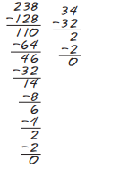

1 | 1 | 1 | 0 | 1 | 1 | 1 | 0 | 238
0 | 0 | 1 | 0 | 0 | 0 | 1 | 0 | 34

011111011 | 123
00110010 | 50
11111111 | 255
11001000 | 200
00001010 | 10
10001010 | 138
00000001 | 1
00001101 | 13
11111010 | 250
01101011 | 107
11100000 | 224
01110010 | 114
11000000 | 192
10101100 | 172
01100100 | 100
01110111 | 119
00111001 | 57
01100010 | 98
10110011 | 179
00000010 | 2
2

Address Class Identification
Address | Class
10.250.1.1 | __A___
150.10.15.0 | __B___
192.14.2.0 | __c__
148.17.9.1 | __b__
193.42.1.1 | __c__
126.8.156.0 | __a__
220.200.23.1 | __c__
230.230.45.58 | __d__
177.100.18.4 | __b__
119.18.45.0 | __a__
249.240.80.78 | __d__
199.155.77.56 | __c__
117.89.56.45 | __a__
215.45.45.0 | __c__
199.200.15.0 | __c__
95.0.21.90 | __a__
33.0.0.0 | __a__
158.98.80.0 | __b__
219.21.56.0 | __c__

3

Network & Host Identification

Circle the network portion of these addresses:
177.100.18.4

119.18.45.0

209.240.80.78

199.155.77.56

117.89.56.45

215.45.45.0

192.200.15.0

95.0.21.90

33.0.0.0

158.98.80.0

217.21.56.0

10.250.1.1

150.10.15.0

192.14.2.0

148.17.9.1

193.42.1.1

126.8.156.0

220.200.23.1
Circle the host portion of these addresses:

10.15.123.50

171.2.199.31

198.125.87.177

223.250.200.222

17.45.222.45

126.201.54.231

191.41.35.112

155.25.169.227

192.15.155.2

123.102.45.254

148.17.9.155

100.25.1.1

195.0.21.98

25.250.135.46

171.102.77.77

55.250.5.5

218.155.230.14

10.250.1.1

4

Network Addresses

Using the IP address and subnet mask shown write out the network address:

188.10.18.2 | ______1_8_8__.__1_0__._0__.__0_________
255.255.0.0
10.10.48.80 | ______1_0__.__1_0__._4__8__. _0_________
255.255.255.0
192.149.24.191 | _________192.149.24.0______________
255.255.255.0
150.203.23.19 | __________150.203.0.0_____________
255.255.0.0
10.10.10.10 | ____________10.0.0.0_____________
255.0.0.0
186.13.23.110 | ____________186.13.23.0_________
255.255.255.0
223.69.230.250 | _____________223.69.0.0_________
255.255.0.0
200.120.135.15 | _____________200.120.135.0__________
255.255.255.0
27.125.200.151 | _____________27.0.0.0____________
255.0.0.0
199.20.150.35 | ___________199.20.150.0____________
255.255.255.0
191.55.165.135 | ____________191.55.165.0____________
255.255.255.0
28.212.250.254 | ____________28.212.0.0_______________
255.255.0.0
 |  | 5

Host Addresses

Using the IP address and subnet mask shown write out the host address:

188.10.18.2 | ______0__._0___. _1_8__._2____________
255.255.0.0
10.10.48.80 | ______0__._0___. _0__._8__0___________
255.255.255.0
222.49.49.11 | ____________0.0.0.11____________
255.255.255.0
128.23.230.19 | _______________0.0.230.19______
255.255.0.0
10.10.10.10 | ___________0.10.10.10__________
255.0.0.0
200.113.123.11 | ___________0.0.0.11____________
255.255.255.0
223.169.23.20 | __________0.0.23.20____________
255.255.0.0
203.20.35.215 | ____________0.0.0.215__________
255.255.255.0
117.15.2.51 | _____________0.15.2.51_________
255.0.0.0
199.120.15.135 | ____________0.0.0.135__________
255.255.255.0
191.55.165.135 | ___________0.0.0.135__________
255.255.255.0
48.21.25.54 | ____________0.0.25.54__________
255.255.0.0
6

Default Subnet Masks

Write the correct default subnet mask for each of the following addresses:

177.100.18.4 | ______2_5__5__.__2_5__5__._0___. _0______
119.18.45.0 | _______2__5_5___. _0__.__0__. _0________
191.249.234.191 | _____________255.255.0.0__________
223.23.223.109 | _________255.255.255.0___________
10.10.250.1 | ________255.0.0.0_______________
126.123.23.1 | _____255.0.0.0___________________
223.69.230.250 | ________255.255.255.0_______________
192.12.35.105 | _________255.255.255.0______________
77.251.200.51 | ___________255.0.0.0_____________
189.210.50.1 | _________255.255.0.0________________
88.45.65.35 | _____________255.0.0.0________________
128.212.250.254 | ____________255.255.0.0____________
193.100.77.83 | __________255.255.255.0_______________
125.125.250.1 | _________255.0.0.0____________________
1.1.10.50 | ___________255.0.0.0__________________
220.90.130.45 | __________255.255.255.0______________
134.125.34.9 | ___________255.255.0.0______________
95.250.91.99 | ____________255.0.0.0_________________
 |  | 7

ANDING With Default subnet masks

Every IP address must be accompanied by a subnet mask. By now you should be able to look at an IP address and tell what class it is. Unfortunately your computer doesn’t think that way.
For your computer to determine the network and subnet portion of an IP address it must “AND” the IP address with the subnet mask.

Default Subnet Masks:
Class A 255.0.0.0 Class B 255.255.0.0
Class C 255.255.255.0

ANDING Equations:
1 AND 1 = 1
1 AND 0 = 0
0 AND 1 = 0
0 AND 0 = 0

Sample:

What you see...
IP Address: 192 . 100 . 10 . 33
What you can figure out in your head...
Address Class: C
Network Portion: 192 . 100 . 10 . 33
Host Portion: 192 . 100 . 10 . 33
In order for you computer to get the same information it must AND the IP address with the subnet mask in binary.

IP Address: Default Subnet Mask:
AND:
Network Host

(192 . 100 . 10 . 33)
1 1 0 0 0 0 0 0 . 0 1 1 0 0 1 0 0 . 0 0 0 0 1 0 1 0 . 0 0 1 0 0 0 0 1
1 1 1 1 1 1 1 1 . 0 1 1 1 1 1 1 1 . 1 1 1 1 1 1 1 1 . 0 0 0 0 0 0 0 0
1 1 0 0 0 0 0 0 . 0 1 1 0 0 1 0 0 . 0 0 0 0 1 0 1 0 . 0 0 0 0 0 0 0 0

(255 . 255 . 255 . 0)
(192 . 100 . 10 . 0)

ANDING with the default subnet mask allows your computer to figure out the network portion of the address.

8

ANDING With Custom subnet masks

When you take a single network such as 192.100.10.0 and divide it into five smaller networks (192.100.10.16, 192.100.10.32, 192.100.10.48, 192.100.10.64, 192.100.10.80) the outside
world still sees the network as 192.100.10.0, but the internal computers and routers see five smaller subnetworks. Each independent of the other. This can only be accomplished by using a custom subnet mask. A custom subnet mask borrows bits from the host portion of the address to create a subnetwork address between the network and host portions of an IP address. In this example each range has 14 usable addresses in it. The computer must still AND the IP address against the custom subnet mask to see what the network portion is and which subnetwork it belongs to.

IP Address: 192 . 100 . 10 . 0
Custom Subnet Mask: 255.255.255.240

Address Ranges: 192.10.10.0 to 192.100.10.15
192.100.10.16 to 192.100.10.31
192.100.10.32 to 192.100.10.47 (Range in the sample below) 192.100.10.48 to 192.100.10.63
192.100.10.64 to 192.100.10.79
192.100.10.80 to 192.100.10.95
192.100.10.96 to 192.100.10.111
192.100.10.112 to 192.100.10.127
192.100.10.128 to 192.100.10.143
192.100.10.144 to 192.100.10.159
192.100.10.160 to 192.100.10.175
192.100.10.176 to 192.100.10.191
192.100.10.192 to 192.100.10.207
192.100.10.208 to 192.100.10.223
192.100.10.224 to 192.100.10.239
192.100.10.240 to 192.100.10.255

Network
Sub Network Host

IP Address: Custom Subnet Mask:
AND:
1 1 0 0 0 0 0 0 . 0 1 1 0 0 1 0 0 . 0 0 0 0 1 0 1 0 . 0 0 1 0 0 0 0 1 (192 . 100 . 10 . 33)
1 1 1 1 1 1 1 1 . 0 1 1 1 1 1 1 1 . 1 1 1 1 1 1 1 1 . 1 1 1 1 0 0 0 0 ₍₂₅₅ . ₂₅₅ . ₂₅₅ . ₂₄₀₎
1 1 0 0 0 0 0 0 . 0 1 1 0 0 1 0 0 . 0 0 0 0 1 0 1 0 . 0 0 1 0 0 0 0 0 (192 . 100 . 10 . 32)

Four bits borrowed from the host portion of the address for the custom subnet mask.
The ANDING process of the four borrowed bits shows which range of IP addresses this particular address will fall into.

In the next set of problems you will determine the necessary information to determine the correct subnet mask for a variety of IP addresses.
9

How to determine the number of subnets and the number of hosts per subnet
Two formulas can provide this basic information:

Number of subnets = 2 s (Second subnet formula: Number of subnets = 2s - 2)

Number of hosts per subnet = 2 h - 2
Both formulas calculate the number of hosts or subnets based on the number of binary bits used. For example if you borrow three bits from the host portion of the address use the number of subnets formula to determine the total number of subnets gained by borrowing the three bits. This would be 23 or 2 x 2 x 2 = 8 subnets
To determine the number of hosts per subnet you would take the number of binary bits used in the host portion and apply this to the number of hosts per subnet formula If five bits are in the host portion of the address this would be 25 or 2 x 2 x 2 x 2 x 2 = 32 hosts.

When dealing with the number of hosts per subnet you have to subtract two addresses from the range. The first address in every range is the subnet number. The last address in every range is the broadcast address. These two addresses cannot be assigned to any device in the network which is why you have to subtract two addresses to find the number of usable addresses in each range.

For example if two bits are borrowed for the network portion of the address you can easily determine the number of subnets and hosts per subnets using the two formulas.
195. 223 . 50 . 0 0 0 0 0 0 0 0
The number of hosts created by leaving 6 bits is 26 - 2 or
2 x 2 x 2 x 2 x 2 x 2 = 64 - 2 = 62
usable hosts per subnet.
The number of subnets created by borrowing 2 bits is 22 or 2 x 2 = 4 subnets.

What about that second subnet formula:
Number of subnets = 2 s - 2
In some instances the first and last subnet range of addresses are reserved. This is similar to the first and last host addresses in each range of addreses.

The first range of addresses is the zero subnet. The subnet number for the zero subnet is also the subnet number for the classful subnet address.

The last range of addresses is the broadcast subnet. The broadcast address for the last subnet in the broadcast subnet is the same as the classful broadcast address.
10

Class C Address unsubnetted:

195. 223 . 50 . 0
195.223.50.0 to 195.223.50.255
Class C Address subnetted (2 bits borrowed):

195. 223 . 50 . 0 0 0 0 0 0 0 0
(Invalid range) (0)
(1) 195.223.50.64 to 195.223.50.127
195.223.50.0
to 195.223.50.63
(Invalid range) (3)
(2)
195.223.50.128 to 195.223.50.191
195.223.50.192 to 195.223.50.255
Notice that the subnet and broadcast addresses match.

The primary reason the the zero and broadcast subnets were not used had to do pirmarily with the broadcast addresses. If you send a broadcast to 195.223.255 are you sending it to all 255 addresses in the classful C address or just the 62 usable addresses in the broadcast range?

The CCNA and CCENT certification exams may have questions which will require you to determine which formula to use, and whehter or not you can use the first and last subnets. Use the chart below to help decide.

When to use which formula to determine the number of subnets
Use the 2s - 2 formula and don’t use the zero and broadcast ranges if... | Use the 2s formula and use the zero and broadcast ranges if...
Classful routing is used | Classless routing or VLSM is used
RIP version 1 is used | RIP version 2, EIGRP, or OSPF is used
The no ip subnet zero command is configured on your router | The ip subnet zero command is configured on your router (default setting)
 | No other clues are given

Bottom line for the CCNA exams; if a question does not give you any clues as to whether or not to allow these two subnets, assume you can use them.
This workbook has you use the number of subnets = 2s formula.

11

Custom Subnet Masks
Problem 1
Number of needed subnets 14
Number of needed usable hosts 14
Network Address 192.10.10.0
Address class ____C______
Default subnet mask ____2__5__5__._2__5__5__._2__5_5___. _0______
Custom subnet mask ____2__5__5__._2__5__5__._2__5_5___. _2__4_0___
Total number of subnets _________1_6_________
Total number of host addresses _________1_6_________
Number of usable addresses _________1_4_________
Number of bits borrowed _________4__________

Show your work for Problem 1 in the space below.

Number of Subnets -

192 . 10 . 10 . 0 0 0 0 0 0 0 0
Number of

Add the binary value numbers to the left of the line to create the custom subnet mask.
128
64
256 128 64 | 32 | 16 | 8 | 4 | 2 | - Hosts
2 4 8 | 16 | 32 | 64 128 256
128 64 32 | 16 | 8 | 4 | 2 | 1 | - Binary values

32
+16
240

Observe the total number of hosts.

Subtract 2 for the number of usable hosts.
16
-2
14

12

Custom Subnet Masks
Problem 2
Number of needed subnets 1000
Number of needed usable hosts 60
Network Address 165.100.0.0
Address class ____B______
Default subnet mask ____2__5__5__._2__5__5__._0__.__0_________
Custom subnet mask ____2__5__5__._2__5__5__._2__5_5___._1_9__2___
Total number of subnets _______1_,0__2_4________
Total number of host addresses _________6_4_________
Number of usable addresses _________6_2_________
Number of bits borrowed _________1_0_________

Show your work for Problem 2 in the space below.

Number of
Hosts -

. 256 128

64 32 16 8 4 2

Add the binary value numbers to the left of the line to create the custom subnet mask.
128
64
Number of Subnets | - |  | 2 | 4 8 | 16 | 32 | 64 | 128 256.
Binary values | - | 128 64 32 |  |  | 16 | 8 | 4 | 2 1 . 128 | 64 | 32 16 | 8 | 4 | 2 | 1
165 . 100 | . | 0 0 0 |  |  | 0 | 0 | 0 | 0 0 . 0 | 0 | 0 0 | 0 | 0 | 0 | 0

32
16
8
4
2
+1
128
+64
192

64
-2 62

Observe the total number of hosts.

Subtract 2 for the number of usable hosts.

255
13

Problem 3
Custom Subnet Masks

Network Address 148.75.0.0 /26
/26 indicates the total number of bits used for the network and subnetwork portion of the address. All bits remaining belong to the host portion of the address.
Address class _____B_____
Default subnet mask _____2_5__5__.__2_5__5__._0___. _0_________
Custom subnet mask _____2_5__5__.__2_5__5__.__2_5__5__._1__9_2___

Total number of subnets _______1_,0__2_4________
Total number of host addresses _________6_4_________
Number of usable addresses _________6_2_________
Number of bits borrowed _________1_0_________

Show your work for Problem 3 in the space below.

Number of
Hosts -

. 256 128

64 32 16 8 4 2

Add the binary value numbers to the left of the line to create the custom subnet mask.
128
64
Number of Subnets | - |  | 2 | 4 8 | 16 32 | 64 | 128 256.
Binary values | - | 128 64 32 |  |  | 16 8 | 4 | 2 1 . 128 | 64 | 32 16 | 8 | 4 | 2 | 1
148 . 75 | . | 0 0 0 |  |  | 0 0 | 0 | 0 0 . 0 | 0 | 0 0 | 0 | 0 | 0 | 0

32
16
8
4
128
+64
192

Observe the total number of hosts.

Subtract 2 for the number of usable hosts.
64
-2
62

2
+1 255
14
1024
-2 1,022

Subtract 2 for the total number of subnets to get the usable number of subnets.

Custom Subnet Masks
Problem 4
Number of needed subnets 6
Number of needed usable hosts 30
Network Address 210.100.56.0

Address class _______

Default subnet mask _______________________________

Custom subnet mask _______________________________

Total number of subnets ___________________

Total number of host addresses ___________________

Number of usable addresses ___________________

Number of bits borrowed ___________________

Show your work for Problem 4 in the space below.

Number of
Number of 256 128 64 32 16 8 4 2 - Hosts

Subnets - 2 4 8
128 64 32

210 . 100 . 56 . 0 0 0
16 32 64 128 256
16 8 4 2 1 - Binary values

0 0 0 0 0

15

Custom Subnet Masks
Problem 5
Number of needed subnets 6
Number of needed usable hosts 30
Network Address 195.85.8.0

Address class _______

Default subnet mask _______________________________

Custom subnet mask _______________________________

Total number of subnets ___________________

Total number of host addresses ___________________

Number of usable addresses ___________________

Number of bits borrowed ___________________

Show your work for Problem 5 in the space below.

Number of
Number of 256 128 64 32 16 8 4 2 - Hosts

Subnets - 2 4 8 16 32 64 128 256

128 | 64 | 32 | 16 | 8 | 4 | 2 | 1 | - Binary values
195 . 85 . 8 . 0 | 0 | 0 | 0 | 0 | 0 | 0 | 0

16

Custom Subnet Masks
Problem 6
Number of needed subnets 126
Number of needed usable hosts 131,070
Network Address 118.0.0.0

Address class _______

Default subnet mask _______________________________

Custom subnet mask _______________________________

Total number of subnets ___________________

Total number of host addresses ___________________

Number of usable addresses ___________________

Number of bits borrowed ___________________

Show your work for Problem 6 in the space below.

Number of
Hosts -

. 256 128 64 32 16 8 4 2

Number of
.
Subnets - 2 4 8 16 32 64 128 256 .
Binary values -128 64 32 16 8 4 2 1 . 128 64 32 16 8 4 2 1 . 128 64 32 16 8 4 2 1
118. 0 0 0 0 0 0 0 0 . 0 0 0 0 0 0 0 0 . 0 0 0 0 0 0 0 0

17

Custom Subnet Masks
Problem 7
Number of needed subnets 2000
Number of needed usable hosts 15
Network Address 178.100.0.0

Address class __________

Default subnet mask _______________________________

Custom subnet mask _______________________________

Total number of subnets ___________________

Total number of host addresses ___________________

Number of usable addresses ___________________

Number of bits borrowed ___________________

Show your work for Problem 7 in the space below.

Number of
Hosts -

Number of

. 256 128 64 32 16 8 4 2

Subnets - 2 4 8 16 32 64 128 256.

Binary values -
128 64 32 16 8 4 2 1 .
128 64 32 16 8 4 2 1

178 . 100 . 0 0 0 0 0 0 0 0 . 0 0 0 0 0 0 0 0

18

Custom Subnet Masks
Problem 8
Number of needed subnets 3
Number of needed usable hosts 45
Network Address 200.175.14.0

Address class _______

Default subnet mask _______________________________

Custom subnet mask _______________________________

Total number of subnets ___________________

Total number of host addresses ___________________

Number of usable addresses ___________________

Number of bits borrowed ___________________

Show your work for Problem 8 in the space below.

19

Custom Subnet Masks
Problem 9
Number of needed subnets 60
Number of needed usable hosts 1,000
Network Address 128.77.0.0

Address class _______

Default subnet mask _______________________________

Custom subnet mask _______________________________

Total number of subnets ___________________

Total number of host addresses ___________________

Number of usable addresses ___________________

Number of bits borrowed ___________________

Show your work for Problem 9 in the space below.

20

Custom Subnet Masks
Problem 10
Number of needed usable hosts 60
Network Address 198.100.10.0

Address class _______

Default subnet mask _______________________________

Custom subnet mask _______________________________

Total number of subnets ___________________

Total number of host addresses ___________________

Number of usable addresses ___________________

Number of bits borrowed ___________________

Show your work for Problem 10 in the space below.

21

Custom Subnet Masks
Problem 11
Number of needed subnets 250
Network Address 101.0.0.0

Address class _______

Default subnet mask _______________________________

Custom subnet mask _______________________________

Total number of subnets ___________________

Total number of host addresses ___________________

Number of usable addresses ___________________

Number of bits borrowed ___________________

Show your work for Problem 11 in the space below.

22

Custom Subnet Masks
Problem 12
Number of needed subnets 5
Network Address 218.35.50.0

Address class _______

Default subnet mask _______________________________

Custom subnet mask _______________________________

Total number of subnets ___________________

Total number of host addresses ___________________

Number of usable addresses ___________________

Number of bits borrowed ___________________

Show your work for Problem 12 in the space below.

23

Custom Subnet Masks
Problem 13
Number of needed usable hosts 25
Network Address 218.35.50.0

Address class _______

Default subnet mask _______________________________

Custom subnet mask _______________________________

Total number of subnets ___________________

Total number of host addresses ___________________

Number of usable addresses ___________________

Number of bits borrowed ___________________

Show your work for Problem 13 in the space below.

24

Custom Subnet Masks
Problem 14
Number of needed subnets 10
Network Address 172.59.0.0

Address class _______

Default subnet mask _______________________________

Custom subnet mask _______________________________

Total number of subnets ___________________

Total number of host addresses ___________________

Number of usable addresses ___________________

Number of bits borrowed ___________________

Show your work for Problem 14 in the space below.

25

Custom Subnet Masks
Problem 15
Number of needed usable hosts 50
Network Address 172.59.0.0

Address class _______

Default subnet mask _______________________________

Custom subnet mask _______________________________

Total number of subnets ___________________

Total number of host addresses ___________________

Number of usable addresses ___________________

Number of bits borrowed ___________________

Show your work for Problem 15 in the space below.

26

Custom Subnet Masks
Problem 16
Number of needed usable hosts 29
Network Address 23.0.0.0

Address class _______

Default subnet mask _______________________________

Custom subnet mask _______________________________

Total number of subnets ___________________

Total number of host addresses ___________________

Number of usable addresses ___________________

Number of bits borrowed ___________________

Show your work for Problem 16 in the space below.

27

Subnetting
Problem 1
Number of needed subnets 14
Number of needed usable hosts 14
Network Address 192.10.10.0
Address class ____C______
Default subnet mask ____2__5__5__._2__5__5__._2__5_5___. _0______
Custom subnet mask ____2__5__5__._2__5__5__._2__5_5___. _2__4_0___
Total number of subnets _________1_6_________
Total number of host addresses _________1_6_________
Number of usable addresses _________1_4_________
Number of bits borrowed _________4__________

What is the 4th
subnet range? 192.10.10.48 to 192.10.10.63
What is the subnet number

for the 8th subnet?

What is the subnet broadcast address for the 13th subnet?

What are the assignable addresses for the 9th
___1_9_2___. _1_0__.__1_0__._1_1__2___

___1_9_2___. _1_0__.__1_0__._2__0_7___

subnet? _1_9__2_._1_0_._1_0__.1_2__9___t_o___1_9_2__.1_0__.1_0__.1__4_2___

28

Number of

Show your work for Problem 1 in the space below.

Number of 256 128 64 32 16 8 4 2 - Hosts

Subnets - 2 4 8 16 32 64 128 256

128 | 64 | 32 | 16 | 8 | 4 | 2 | 1 - | Binary values
192. 10 . 10 . 0 | 0 | 0 | 0 | 0 | 0 | 0 | 0

(0) 0
(1) 0
(2) 0
(3) 0
(4) 0
(5) 0
(6) 0
(7) 0
(8) 1
(9) 1
(10) 1
(11) 1
(12) 1
(13) 1
(14) 1
(15) 1
0 0 0
0 0 1
0 1 0
0 1 1
1 0 0
1 0 1
1 1 0
1 1 1
0 0 0
0 0 1
0 1 0
0 1 1
1 0 0
1 0 1
1 1 0
1 1 1
192.10.10.0 to 192.10.10.15
192.10.10.16 to 192.10.10.31
192.10.10.32 to 192.10.10.47
192.10.10.48 to 192.10.10.63
192.10.10.64 to 192.10.10.79
192.10.10.80 to 192.10.10.95
192.10.10.96 to 192.10.10.111
192.10.10.112 to 192.10.10.127
192.10.10.128 to 192.10.10.143
192.10.10.144 to 192.10.10.159
192.10.10.160 to 192.10.10.175
192.10.10.176 to 192.10.10.191
192.10.10.192 to 192.10.10.207
192.10.10.208 to 192.10.10.223
192.10.10.224 to 192.10.10.239
192.10.10.240 to 192.10.10.255

Custom subnet
mask
128
64
32
+16
240

16
Usable subnets -2
14

16
Usable hosts -2
14

The binary value of the last bit borrowed is the range. In this problem the range is 16.

The first address in each subnet range is the subnet number.

The last address in each subnet range is the subnet broadcast address.
29

Subnetting
Problem 2
Number of needed subnets 1000
Number of needed usable hosts 60
Network Address 165.100.0.0
Address class ____B______
Default subnet mask ____2__5__5__._2__5__5__._0__.__0_________
Custom subnet mask ____2__5__5__._2__5__5__._2__5_5___._1_9__2___
Total number of subnets _______1_,0__2_4________
Total number of host addresses _________6_4_________
Number of usable addresses _________6_2_________
Number of bits borrowed _________1_0_________

What is the 15th
subnet range? 165.100.3.128 to 165.100.3.191
What is the subnet number

for the 6th subnet?

What is the subnet broadcast address for
the 6th subnet?

What are the assignable addresses for the 9th
___1_6_5___. _1_0__0__. _1__._6__4____

___1_6_5___. _1_0__0__._1__._1__2_7___

subnet? _1_6__5_._1_0__0_._2_._1__t_o___1_6__5_._1_0_0__.0__.6__2______

30

Number of
Hosts -

Number of

. 256 128

64 32 16 8 4 2

Subnets - 2 4 8 16 32 64 128 256.
Binary values - 128 64 32 16 8 4 2 1 . 128 64 32 16 8 4 2 1

165 . 100 . 0 0 0 0 0 0 0 0 . 0 0 0 0 0 0 0 0

64

Usable -2
hosts 62

128
64
32
16
(0)
(1)
(2)
(3)
(4)
(5)
. 0
1
1
0
1
1
1 . 0 0
1 . 0 1
165.100.0.0 to 165.100.0.63
165.100.0.64 to 165.100.0.127
165.100.0.128 to 165.100.0.191
165.100.0.192 to 165.100.0.255
165.100.1.0 to 165.100.1.63
165.100.1.64 to 165.100.1.127

Custom subnet mask
128
+64
192
8 (6)
4 (7)
2 (8)
1 . 1 0
1 . 1 1
1 0 . 0 0
165.100.1.128 to 165.100.1.191
165.100.1.192 to 165.100.1.255
165.100.2.0 to 165.100.0.63

The binary value of the last bit borrowed is the range. In this problem the range is 64.
+1 255
(9) 1 0 . 0 1
(10) 1 0 . 1 0
165.100.2.64 to 165.100.0.127
165.100.2.128 to 165.100.0.191

The first address in each subnet range is the subnet number.

The last address in each subnet range is the subnet broadcast address.
(11) 1 0 . 1 1
(12)
1
1 .
0
0
(13) 1 1 . 0 1
(14) 1 1 . 1 0
(15) 1 1 . 1 1
165.100.2.192 to 165.100.0.255
165.100.3.0 to 165.100.3.63
165.100.3.64 to 165.100.3.127
165.100.3.128 to 165.100.3.191
165.100.3.192 to 165.100.3.255

Down to

(1022) 1 1 1 1 1 1
Show
your
work
for
Problem 2
in
the
space
below.
(1023) 1 1 1 1 1 1
31
1 1 . 1
1 1 . 1
0 165.100.255.128 to 165.100.255.191
1 165.100.255.192 to 165.100.255.255

Subnetting
Problem 3
Number of needed subnets 2
Network Address 195.223.50.0

Address class __________

Default subnet mask _______________________________

Custom subnet mask _______________________________

Total number of subnets ___________________

Total number of host addresses ___________________

Number of usable addresses ___________________

Number of bits borrowed ___________________

What is the 3rd
subnet range?

What is the subnet number for the 2nd subnet?

What is the subnet broadcast address for
the 1st subnet?

________________________

________________________

What are the assignable addresses for the 3rd
subnet? ______________________________________

32

Show your work for Problem 3 in the space below.

Number of Subnets | - | 256 128 64  2 4 8 |  |  | 32  16 | 16  32 | 8 4  64 128 |  | 2  256 | - | Number of Hosts
128 |  |  | 64 | 32 | 16 | 8 | 4 | 2 | 1 | - Binary values
195. 223 . 50 . 0 |  |  | 0 | 0 | 0 | 0 | 0 | 0 | 0

33

Subnetting
Problem 4
Number of needed subnets 750
Network Address 190.35.0.0

Address class __________

Default subnet mask _______________________________

Custom subnet mask _______________________________

Total number of subnets ___________________

Total number of host addresses ___________________

Number of usable addresses ___________________

Number of bits borrowed ___________________

What is the 15th
subnet range?

What is the subnet number for the 13th subnet?

What is the subnet broadcast address for the 10th subnet?

What are the assignable addresses for the 6th
subnet?

________________________

________________________

______________________________________

34

Show your work for Problem 4 in the space below.

35

Subnetting
Problem 5
Number of needed usable hosts 6
Network Address 126.0.0.0

Address class __________

Default subnet mask _______________________________

Custom subnet mask _______________________________

Total number of subnets ___________________

Total number of host addresses ________________

Number of usable addresses ___________________

Number of bits borrowed ___________________

What is the 2nd
subnet range?

What is the subnet number for the 5th subnet?

What is the subnet broadcast address for
the 7th subnet?

________________________

________________________

What are the assignable addresses for the 10th
subnet? ______________________________________

36

Show your work for Problem 5 in the space below.

37

Subnetting
Problem 6
Number of needed subnets 10
Network Address 192.70.10.0

Address class __________

Default subnet mask _______________________________

Custom subnet mask _______________________________

Total number of subnets ___________________

Total number of host addresses ___________________

Number of usable addresses ___________________

Number of bits borrowed ___________________

What is the 9th
subnet range?

What is the subnet number for the 4th subnet?

What is the subnet broadcast address for the 12th subnet?

________________________

________________________

What are the assignable addresses for the 10th
subnet? ______________________________________

38

Show your work for Problem 6 in the space below.

39

Problem 7
Subnetting

Network Address 10.0.0.0 /16

Address class __________

Default subnet mask _______________________________

Custom subnet mask _______________________________

Total number of subnets ___________________

Total number of host addresses ___________________

Number of usable addresses ___________________

Number of bits borrowed ___________________

What is the 11th
subnet range?

What is the subnet number for the 6th subnet?

What is the subnet broadcast address for the 2nd subnet?

________________________

________________________

What are the assignable addresses for the 9th
subnet? ______________________________________

40

Show your work for Problem 7 in the space below.

41

Subnetting
Problem 8
Number of needed subnets 5
Network Address 172.50.0.0

Address class __________

Default subnet mask _______________________________

Custom subnet mask _______________________________

Total number of subnets ___________________

Total number of host addresses ___________________

Number of usable addresses ___________________

Number of bits borrowed ___________________

What is the 4th
subnet range?

What is the subnet number for the 5th subnet?

What is the subnet broadcast address for
the 6th subnet?

________________________

________________________

What are the assignable addresses for the 3rd
subnet? ______________________________________

42

Show your work for Problem 8 in the space below.

43

Subnetting
Problem 9
Number of needed usable hosts 28
Network Address 172.50.0.0

Address class __________

Default subnet mask _______________________________

Custom subnet mask _______________________________

Total number of subnets ___________________

Total number of host addresses ___________________

Number of usable addresses ___________________

Number of bits borrowed ___________________

What is the 2nd
subnet range?

What is the subnet number for the 10th subnet?

What is the subnet broadcast
address for the 4th subnet?

________________________

________________________

What are the assignable addresses for the 6th
subnet? ______________________________________

44

Show your work for Problem 9 in the space below.

45

Subnetting
Problem 10
Number of needed subnets 45
Network Address 220.100.100.0

Address class __________

Default subnet mask _______________________________

Custom subnet mask _______________________________

Total number of subnets ___________________

Total number of host addresses ___________________

Number of usable addresses ___________________

Number of bits borrowed ___________________

What is the 5th
subnet range?

What is the subnet number for the 4th subnet?

What is the subnet broadcast address for the 13th subnet?

________________________

________________________

What are the assignable addresses for the 12th
subnet? ______________________________________

46

Show your work for Problem 10 in the space below.

47

Subnetting
Problem 11
Number of needed usable hosts 8,000
Network Address 135.70.0.0

Address class __________

Default subnet mask _______________________________

Custom subnet mask _______________________________

Total number of subnets ___________________

Total number of host addresses ___________________

Number of usable addresses ___________________

Number of bits borrowed ___________________

What is the 6th
subnet range?

What is the subnet number for the 7th subnet?

What is the subnet broadcast address for the 3rd subnet?

________________________

________________________

What are the assignable addresses for the 5th
subnet? ______________________________________

48

Show your work for Problem 11 in the space below.

49

Subnetting
Problem 12
Number of needed usable hosts 45
Network Address 198.125.50.0

Address class __________

Default subnet mask _______________________________

Custom subnet mask _______________________________

Total number of subnets ___________________

Total number of host addresses ___________________

Number of usable addresses ___________________

Number of bits borrowed ___________________

What is the 2nd
subnet range?

What is the subnet number for the 2nd subnet?

What is the subnet broadcast address for
the 4th subnet?

________________________

________________________

What are the assignable addresses for the 3rd
subnet? ______________________________________

50

Show your work for Problem 12 in the space below.

51

Problem 13
Subnetting

Network Address 165.200.0.0 /26

Address class __________

Default subnet mask _______________________________

Custom subnet mask _______________________________

Total number of subnets ___________________

Total number of host addresses ___________________

Number of usable addresses ___________________

Number of bits borrowed ___________________

What is the 10th
subnet range?

What is the subnet number for the 11th subnet?

What is the subnet broadcast address for the 1023rd subnet?

________________________

________________________

What are the assignable addresses for the 1022nd
subnet? ______________________________________

52

Show your work for Problem 13 in the space below.

53

Subnetting
Problem 14
Number of needed usable hosts 16
Network Address 200.10.10.0

Address class __________

Default subnet mask _______________________________

Custom subnet mask _______________________________

Total number of subnets ___________________

Total number of host addresses ___________________

Number of usable addresses ___________________

Number of bits borrowed ___________________

What is the 7th
subnet range?

What is the subnet number for the 5th subnet?

What is the subnet broadcast address for
the 4th subnet?

________________________

________________________

What are the assignable addresses for the 6th
subnet? ______________________________________

54

Show your work for Problem 14 in the space below.

55

Problem 15
Subnetting

Network Address 93.0.0.0 \19

Address class __________

Default subnet mask _______________________________

Custom subnet mask _______________________________

Total number of subnets ___________________

Total number of host addresses ___________________

Number of usable addresses ___________________

Number of bits borrowed ___________________

What is the 15th
subnet range?

What is the subnet number for the 9th subnet?

What is the subnet broadcast address for
the 7th subnet?

________________________

________________________

What are the assignable addresses for the 12th
subnet? ______________________________________

56

Show your work for Problem 15 in the space below.

57

Practical Subnetting 1
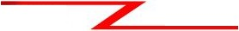Based on the information in the graphic shown, design a network addressing scheme that will supply the minimum number of subnets, and allow enough extra subnets and hosts for 100% growth in both areas. Circle each subnet on the graphic and answer the questions below.
IP Address 172.16.0.0
F0/0
Router A
S0/0/0
S0/0/1
F0/0
F0/1
Router B
Marketing 24 Hosts
Reasearch 60 Hosts
Management 15 Hosts

Address class Custom subnet mask
Minimum number of subnets needed
Extra subnets required for 100% growth
(Round up to the next whole number)

Total number of subnets needed
Number of host addresses in the largest subnet group
Number of addresses needed for
______________B_______________
_______2__5_5_._2_5__5_._2_2_4__.0________
____4_____
_+___4_____
_=___8_____
____6_0____
+ 60

100% growth in the largest subnet
(Round up to the next whole number)

Total number of address needed for the largest subnet
_________

_=__1_2_0____

Start with the first subnet and arrange your sub-networks from the largest group to the smallest.

IP address range for Research IP address range for Marketing
IP address range for Management
IP address range for Router A to Router B serial connection
58
___1_7_2__.1_6_._0_._0__t_o_1_7_2__.3_1__.2_5__5___
__1__7_2_.1_6__.3_2__.0__t_o__1_7_2_._6_3_._2_5__5__
__1_7__2_.1_6__.6_4__.0__t_o__1_7_2_._9_5_._2_5__5__
__1_7_2__.1_6_._9_6_._0__t_o_1_7_2__.1_2__7_.2_5__5__

Number of
Hosts -

. 256 128 64 32 16 8 4 2

Number of Subnets | - |  | 2 | 4 8 | 16 32 64 128 256.
Binary values | - | 128 64 32 |  |  | 16 8 4 2 | 1 . 128 64 32 16 | 8 | 4 | 2 | 1
172 . 16 | . | 0 0 0 |  |  | 0 0 0 0 | 0 . 0 0 0 0 | 0 | 0 | 0 | 0

4 x1.0
4
60 x1.0
60
(0) 0
(1) 1
(2) 1 0
(3) 1 1
(4) 1 0 0
(5) 1 0 1
(6) 1 1 0
(7) 1 1 1
172.16.0.0
172.16.32.0
172.16.64.0
172.16.96.0
172.16.128.0
172.16.160.0
172.16.192.0
172.16.224.0
to 172.16.31.255
to 172.16.63.255
to 172.16.95.255
to 172.16.127.255
to 172.16.159.255
to 172.16.191.255
to 172.16.223.255
to 172.16.255.255

Show
your
work
for
Practical
Subnetting
1
in
the
space
below.
59

Practical Subnetting 2
Based on the information in the graphic shown, design a network addressing scheme that will supply the minimum number of hosts per subnet, and allow enough extra subnets and hosts for 30% growth in all areas. Circle each subnet on the graphic and answer the questions below.

Address class Custom subnet mask
Minimum number of subnets needed
Extra subnets required for 30% growth
(Round up to the next whole number)

Total number of subnets needed
Number of host addresses in the largest subnet group
______________B_______________
______2_5__5_._2_5_5__.2__5_5__.2_2__4______
_____5____
_+____2____
_=____7____
____2_0____

Number of addresses needed for + 6

30% growth in the largest subnet
(Round up to the next whole number)

Total number of address needed for the largest subnet
_________

_=___2_6____

Start with the first subnet and arrange your sub-networks from the largest group to the smallest.

IP address range for Tech Ed IP address range for English IP address range for Science
IP address range for Router A to Router B serial connection
IP address range for Router A
_1_3__5_._1_2_6_._0_.0___to__1_3_5__.1_2__6_.0__.3_1__
_1_3_5_._1_2_6_._0_._3_2__t_o__1_3_5_._1_2_6__.0_._6_3_
_1_3_5_._1_2_6_._0_._6_4__t_o__1_3_5_._1_2_6_._0_._9_5_
1_3__5_.1_2__6_.0__.9_6__t_o__1_3_5__.1_2__6_.0__.1_2_7_

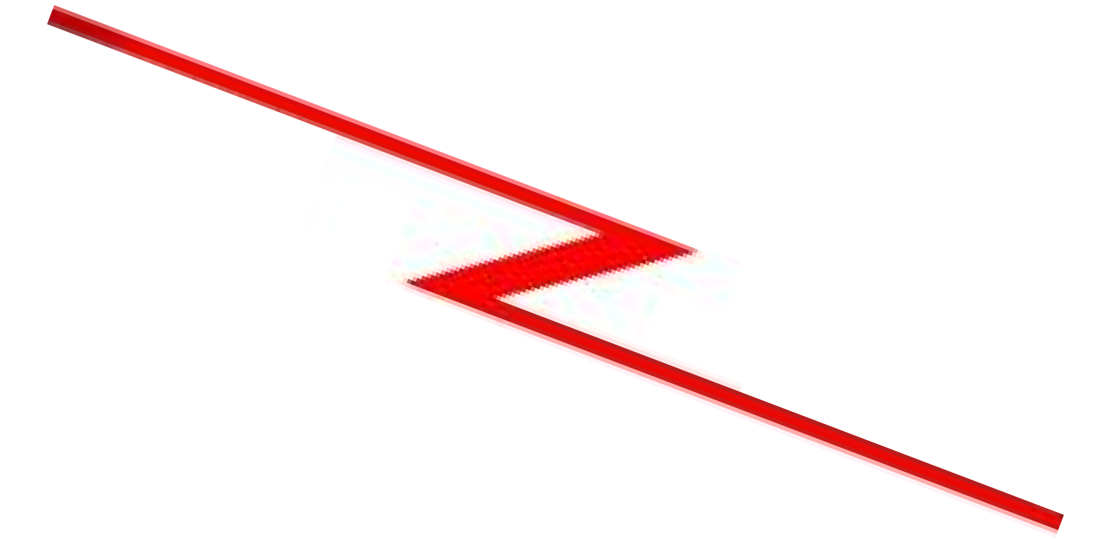to Router B serial connection1_3_5_._1_2_6_._0_._1_2_8__t_o__1_3_5_._1_2_6_._0_.1__5_9
IP Address 135.126.0.0
S0/0/0
F0/0
Router A S0/0/1
S0/0/1
F0/0
Router B
F0/1
S0/0/0
Tech Ed Lab 20 Hosts
F0/1
Router C
Science Lab 10 Hosts
English Department 15 Hosts
60

Number of
Hosts -

Number of

. 256 128 64 32 16 8 4 2

Subnets - 2 4 8 16 32 64 128 256.

Binary values -
128 64 32 16 8 4 2 1 .
128 64 32
16 8 4 2 1

135. 126 . 0 0 0 0 0 0 0 0 . 0 0 0 0 0 0 0 0

5
x.3
1.5
(Round up to 2)

20
x.3
6
(0) . 0
(1) 1
(2) 1 0
(3) 1 1
(4) 1 0 0
(5) 1 0 1
(6) 1 1 0
(7) 1 1 1
(8) 1 . 0 0 0
(9) 1 . 0 0 1
(10) 1 . 0 1 0
(11) 1 . 0 1 1
(12) 1 1 0 0
.
(13) 1 . 1 0 1
(14) 1 . 1 1 0
(15) 1 . 1 1 1
135.126.0.0 to
135.126.0.32 to
135.126.0.64 to
135.126.0.96 to
135.126.0.128 to
135.126.0.160 to
135.126.0.192 to
135.126.0.224 to
135.126.1.0 to
135.126.1.32 to
135.126.1.64 to
135.126.1.96 to
135.126.1.128 to
135.126.1.160 to
135.126.1.192 to
135.1261.224 to
135.126.0.31
135.126.0.63
135.126.0.95
135.126.0.127
135.126.0.159
135.126.0.191
135.126.0.223
135.126.0.255
135.126.1.31
135.126.1.63
135.126.1.95
135.126.1.127
135.126.1.159
135.126.1.191
135.126.1.223
135.126.1.255

Show
your
work
for
Problem 2
in
the
space
below.
61

Practical Subnetting 3
Based on the information in the graphic shown, design a classfull network addressing scheme that will supply the minimum number of hosts per subnet, and allow enough extra subnets and hosts for 25% growth in all areas. Circle each subnet on the graphic and answer the questions below.

IP Address 172.16.0.0

Administrative

F0/0

Router A

S0/0/1

F0/0

Sales 185 Hosts

30 Hosts
F0/1 S0/0/0
Router B

Marketing 50 Hosts

Address class Custom subnet mask
Minimum number of subnets needed
Extra subnets required for 25% growth
(Round up to the next whole number)

Total number of subnets needed
Number of host addresses in the largest subnet group
Number of addresses needed for 25% growth in the largest subnet
(Round up to the next whole number)

Total number of address needed for the largest subnet
_____________________________
_____________________________
_________
_+________
_=________

_________

_+________

_=________

Start with the first subnet and arrange your sub-networks from the largest group to the smallest.

IP address range for Sales IP address range for Marketing
IP address range for Administrative
IP address range for Router A to Router B serial connection
_____________________________
_____________________________
_____________________________

_____________________________

62

Show your work for Problem 3 in the space below.

63

Practical Subnetting 4
Based on the information in the graphic shown, design a network addressing scheme that will supply the minimum number of subnets, and allow enough extra subnets and hosts for 70% growth in all areas. Circle each subnet on the graphic and answer the questions below.

IP Address 135.126.0.0
F0/0 S0/0/0

Router A
S0/0/1
S0/0/1
F0/0

S0/0/0

Router B

Dallas 150 Hosts

F0/1
Router C F0/0

New York

Washington D.C. 220 Hosts
325 Hosts

Address class Custom subnet mask
Minimum number of subnets needed
Extra subnets required for 70% growth
(Round up to the next whole number)

Total number of subnets needed
Number of host addresses in the largest subnet group
Number of addresses needed for 70% growth in the largest subnet
(Round up to the next whole number)

Total number of address needed for the largest subnet
_____________________________
_____________________________
_________
_+________
_=________

_________

_+________

_=________

Start with the first subnet and arrange your sub-networks from the largest group to the smallest.

IP address range for New York IP address range for Washington D. C. IP address range for Dallas
IP address range for Router A to Router B serial connection
IP address range for Router A to Router C serial connection
_____________________________
_____________________________
_____________________________

_____________________________

_____________________________

64

Show your work for Problem 4 in the space below.

65

Practical Subnetting 5
Based on the information in the graphic shown, design a network addressing scheme that will supply the minimum number of hosts per subnet, and allow enough extra subnets and hosts for 100% growth in all areas. Circle each subnet on the graphic and answer the questions below.

IP Address 210.15.10.0

F0/1
F0/0

Science Room 10 Hosts
Tech Ed Lab 18 Hosts

English classroom 15 Hosts

Art Classroom 12 Hosts

Address class Custom subnet mask
Minimum number of subnets needed
Extra subnets required for 100% growth
(Round up to the next whole number)

Total number of subnets needed
Number of host addresses in the largest subnet group
Number of addresses needed for 100% growth in the largest subnet
(Round up to the next whole number)

Total number of address needed for the largest subnet
_____________________________
_____________________________
_________
_+________
_=________

_________

_+________

_=________

Start with the first subnet and arrange your sub-networks from the largest group to the smallest.

IP address range for Router F0/0 Port IP address range for Router F0/1 Port
_____________________________

_____________________________

66

Show your work for Problem 5 in the space below.

67

Practical Subnetting 6
Based on the information in the graphic shown, design a network addressing scheme that will supply the minimum number of subnets, and allow enough extra subnets and hosts for 20% growth in all areas. Circle each subnet on the graphic and answer the questions below.
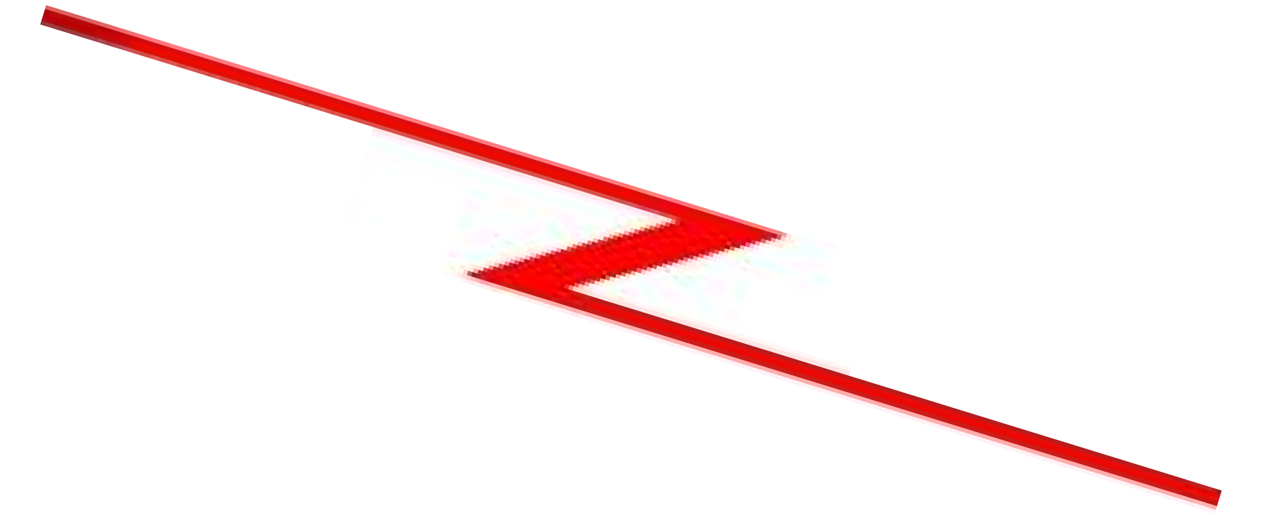
S0/0/0
IP Address 10.0.0.0
Router A
F0/0
S0/0/1
S0/0/1
S0/0/0
Router B
F0/1
Technology Building 320 Hosts
S0/0/0
Art & Drama
S0/0/1
75 Hosts
Router C
F0/0
F0/1
Administration 35 Hosts
Science Building 225 Hosts

Address class Custom subnet mask
Minimum number of subnets needed
Extra subnets required for 20% growth
(Round up to the next whole number)

Total number of subnets needed
_____________________________
_____________________________
_________
_+________
_=________

Start with the first subnet and arrange your sub-networks from the largest group to the smallest.

IP address range for Technology IP address range for Science
IP address range for Arts & Drama IP Address range Administration
IP address range for Router A to Router B serial connection
IP address range for Router A to Router C serial connection
IP address range for Router B to Router C serial connection
_____________________________
_____________________________
_____________________________
_____________________________

_____________________________

_____________________________

_____________________________

68

Show your work for Problem 6 in the space below.

69

Practical Subnetting 7
Based on the information in the graphic shown, design a network addressing scheme that will supply the minimum number of hosts per subnet, and allow enough extra subnets and hosts for 125% growth in all areas. Circle each subnet on the graphic and answer the questions below.

IP Address 177.135.0.0
S0/0/0

Router A
F0/0
S0/0/0 F0/0
Router B
F0/1

Marketing 75 Hosts
Administration
33 Hosts Sales
255 Hosts

Research 135 Hosts

Deployment 63 Hosts

Address class Custom subnet mask
Minimum number of subnets needed
Extra subnets required for 125% growth
(Round up to the next whole number)

Total number of subnets needed
Number of host addresses in the largest subnet group
Number of addresses needed for 125% growth in the largest subnet
(Round up to the next whole number)

Total number of address needed for the largest subnet
_____________________________
_____________________________
_________
_+________
_=________

_________

_+________

_=________

Start with the first subnet and arrange your sub-networks from the largest group to the smallest.

IP address range for Router A Port F0/0 IP address range for Research IP address range for Deployment
IP address range for Router A to Router B serial connection
_____________________________
_____________________________
_____________________________

_____________________________



70

Show your work for Problem 7 in the space below.

71

Practical Subnetting 8
Based on the information in the graphic shown, design a network addressing scheme that will supply the minimum number subnets, and allow enough extra subnets and hosts for 85% growth in all areas. Circle each subnet on the graphic and answer the questions below.

F0/0

Router A
IP Address 192.168.1.0 S0/0/0
S0/0/1
F0/0

Router B

F0/1

New York 8 Hosts

Boston
5 Hosts Research & Development
8 Hosts

Address class Custom subnet mask
Minimum number of subnets needed
Extra subnets required for 85% growth
(Round up to the next whole number)

Total number of subnets needed
Number of host addresses in the largest subnet group
Number of addresses needed for 85% growth in the largest subnet
(Round up to the next whole number)

Total number of address needed for the largest subnet
_____________________________
_____________________________
_________
_+________
_=________

_________

_+________

_=________

Start with the first subnet and arrange your sub-networks from the largest group to the smallest.

IP address range for Router A F0/0 IP address range for New York

IP address range for Router A to Router B serial connection
_____________________________
_____________________________

_____________________________

72

Show your work for Problem 8 in the space below.

73

Practical Subnetting 9
Based on the information in the graphic shown, design a network addressing scheme that will supply the minimum number of hosts per subnet, and allow enough extra subnets and hosts for 15% growth in all areas. Circle each subnet on the graphic and answer the questions below.
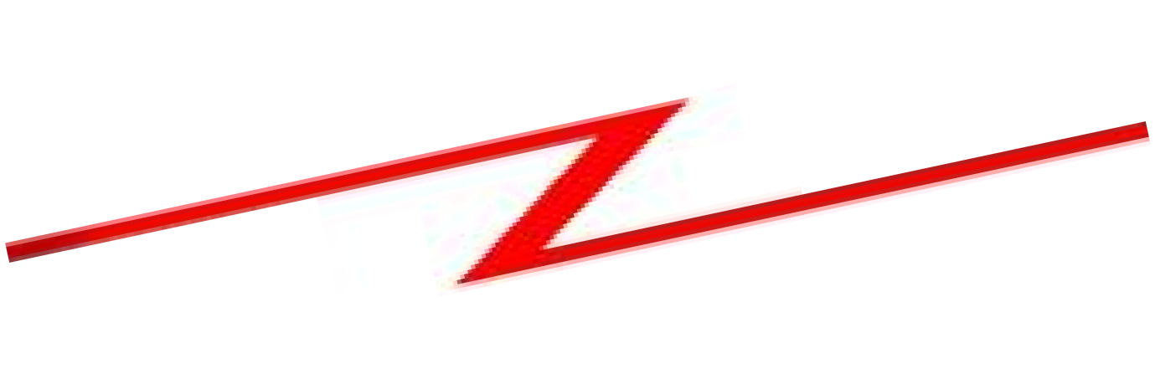
Router A
IP Address 148.55.0.0 S0/0/0
S0/0/1
F0/1
S0/0/1
F0/0
Router B
S0/0/0
Dallas 1500 Hosts
F0/0
Router C
S0/0/1
Router D S0/0/0

Ft. Worth
2300 Hosts
Address class Custom subnet mask
_____________________________
_____________________________

Minimum number of subnets needed
Extra subnets required for 15% growth
(Round up to the next whole number)

Total number of subnets needed
Number of host addresses in the largest subnet group
Number of addresses needed for 15% growth in the largest subnet
(Round up to the next whole number)

Total number of address needed for the largest subnet
_________
_+________
_=________

_________

_+________

_=________

Start with the first subnet and arrange your sub-networks from the largest group to the smallest.

IP address range for Ft. Worth
IP address range for Dallas
IP address range for Router A to Router B serial connection
IP address range for Router A to Router C serial connection
IP address range for Router C
74 to Router D serial connection
_____________________________
_____________________________
_____________________________

_____________________________

_____________________________

Show your work for Problem 9 in the space below.

75

Practical Subnetting 10
Based on the information in the graphic shown, design a network addressing scheme that will supply the minimum number of subnets, and allow enough extra subnets and hosts for 110% growth in all areas. Circle each subnet on the graphic and answer the questions below.

IP Address 172.16.0.0
Sales
115 Hosts
Marketing 56 Hosts
F0/0
S0/0/0
F0/0
Router A S0/0/1
Router B
F0/1
Management 25 Hosts
Research 35 Hosts

Address class Custom subnet mask
Minimum number of subnets needed
Extra subnets required for 110% growth
(Round up to the next whole number)

Total number of subnets needed
Number of host addresses in the largest subnet group
Number of addresses needed for 110% growth in the largest subnet
(Round up to the next whole number)

Total number of address needed for the largest subnet
_____________________________
_____________________________
_________
_+________
_=________

_________

_+________

_=________

Start with the first subnet and arrange your sub-networks from the largest group to the smallest.

IP address range for Sales/Managemnt IP address range for Marketing IP address range for Research
IP address range for Router A to Router B serial connection
_____________________________
_____________________________
_____________________________

_____________________________

76

Show your work for Problem 10 in the space below.

77

Valid and Non-Valid IP Addresses

Using the material in this workbook identify which of the addresses below are correct and usable. If they are not usable addresses explain why.

IP Address: 0.230.190.192
_T__h_e_n_e_t_w__o_r_k__I_D___c_a_n_n_o_t__b_e__0__. __

Subnet Mask: 255.0.0.0 ________________________________
Reference Page Inside Front Cover

IP Address: 192.10.10.1
_O__K_____________________________

Subnet Mask: 255.255.255.0 ________________________________
Reference Pages 28-29

IP Address: 245.150.190.10 ________________________________
Subnet Mask: 255.255.255.0 ________________________________
Reference Page Inside Front Cover

IP Address: 135.70.191.255 ________________________________
Subnet Mask: 255.255.254.0 ________________________________
Reference Pages 48-49

IP Address: 127.100.100.10 ________________________________
Subnet Mask: 255.0.0.0 ________________________________
Reference Pages Inside Front Cover

IP Address: 93.0.128.1 ________________________________
Subnet Mask: 255.255.224.0 ________________________________
Reference Pages 56-57

IP Address: 200.10.10.128 ________________________________
Subnet Mask: 255.255.255.224 ________________________________
Reference Pages 54-55

IP Address: 165.100.255.189 ________________________________
Subnet Mask: 255.255.255.192 ________________________________
Reference Pages 30-31

IP Address: 190.35.0.10 ________________________________
Subnet Mask: 255.255.255.192 ________________________________
Reference Pages 34-35

IP Address: 218.35.50.195 ________________________________
Subnet Mask: 255.255.0.0 ________________________________
Reference Page Inside Front Cover

IP Address: 200.10.10.175 /22 ________________________________

Reference Pages 54-55 and/or Inside Front Cover
________________________________

IP Address: 135.70.255.255 ________________________________
Subnet Mask: 255.255.224.0 ________________________________
Reference Pages 48-49
78

IP Address Breakdown

/24 | /25 | /26 | /27 | /28 | /29 | /30
8+8+8 | 8+8+8+1 | 8+8+8+2 | 8+8+8+3 | 8+8+8+4 | 8+8+8+5 | 8+8+8+6
255.255.255.0 | 255.255.255.128 | 255.255.255.192 | 255.255.255.224 | 255.255.255.240 | 255.255.255.248 | 255.255.255.252
256 Hosts | 128 Hosts | 64 Hosts | 32 Hosts | 16 Hosts | 8 Hosts | 4 Hosts
0-255 | 0-127 | 0-63 |  | 0-15 | 0-7 | 0-3
 |  |  |  |  |  | 4-7
 |  |  |  |  | 8-15 | 8-11
 |  |  |  |  |  | 12-15
 |  |  |  | 16-31 | 16-23 | 16-19
 |  |  |  |  |  | 20-23
 |  |  |  |  | 24-31 | 24-27
 |  |  |  |  |  | 28-31
 |  |  |  | 32-47 | 32-39 | 32-35
 |  |  |  |  |  | 36-39
 |  |  |  |  | 40-47 | 40-43
 |  |  |  |  |  | 44-47
 |  |  |  | 48-63 | 48-55 | 48-51
 |  |  |  |  |  | 52-55
 |  |  |  |  | 56-63 | 56-59
 |  |  |  |  |  | 60-63
 |  | 64-127 |  | 64-79 | 64-71 | 64-67
 |  |  |  |  |  | 68-71
 |  |  |  |  | 72-79 | 72-75
 |  |  |  |  |  | 76-79
 |  |  |  | 80-95 | 80-87 | 80-83
 |  |  |  |  |  | 84-87
 |  |  |  |  | 88-95 | 88-91
 |  |  |  |  |  | 92-95
 |  |  |  | 96-111 | 96-103 | 96-99
 |  |  |  |  |  | 100-103
 |  |  |  |  | 104-111 | 104-107
 |  |  |  |  |  | 108-111
 |  |  |  | 112-127 | 112-119 | 112-115
 |  |  |  |  |  | 116-119
 |  |  |  |  | 120-127 | 120-123
 |  |  |  |  |  | 124-127
 | 128-255 | 128-191 |  | 128-143 | 128-135 | 128-131
 |  |  |  |  |  | 132-135
 |  |  |  |  | 136-143 | 136-139
 |  |  |  |  |  | 140-143
 |  |  |  | 144-159 | 144-151 | 144-147
 |  |  |  |  |  | 148-151
 |  |  |  |  | 152-159 | 152-155
 |  |  |  |  |  | 156-159
 |  |  |  | 160-175 | 16-167 | 160-163
 |  |  |  |  |  | 164-167
 |  |  |  |  | 168-175 | 168-171
 |  |  |  |  |  | 172-175
 |  |  |  | 176-191 | 176-183 | 176-179
 |  |  |  |  |  | 180-183
 |  |  |  |  | 184-191 | 184-187
 |  |  |  |  |  | 188-191
 |  | 192-255 |  | 192-207 | 192-199 | 192-195
 |  |  |  |  |  | 196-199
 |  |  |  |  | 200-207 | 200-203
 |  |  |  |  |  | 204-207
 |  |  |  | 208-223 | 208-215 | 208-211
 |  |  |  |  |  | 212-215
 |  |  |  |  | 216-223 | 216-219
 |  |  |  |  |  | 220-223
 |  |  |  | 224-239 | 224-231 | 224-227
 |  |  |  |  |  | 228-231
 |  |  |  |  | 232-239 | 232-235
 |  |  |  |  |  | 236-239
 |  |  |  | 240-255 | 240-247 | 240-243
 |  |  |  |  |  | 244-247
 |  |  |  |  | 248-255 | 248-251
 |  |  |  |  |  | 252-255
79

Visualizing Subnets Using The Box Method

The box method is the simplest way to visualize the breakdown of subnets and addresses into smaller sizes.

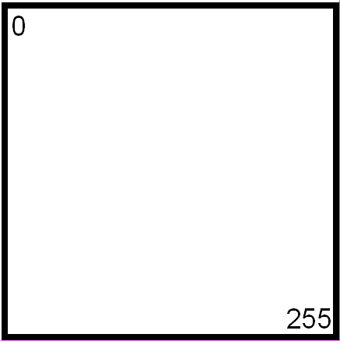Start with a square. The whole square is a single subnet comprised of 256
addresses.

/24 255.255.255.0
256 Hosts

1 Subnet

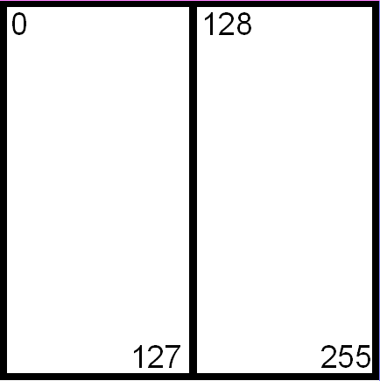Split the box in half and you get two subnets with 128 addresses,

/25 255.255.255.128
128 Hosts

2 Subnets

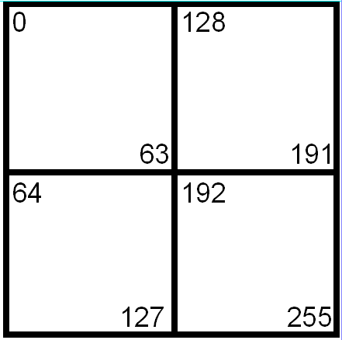Divide the box into quarters and you get four subnets with 64 addresses,

/26 255.255.255.192
64 Hosts

4 Subnets
80

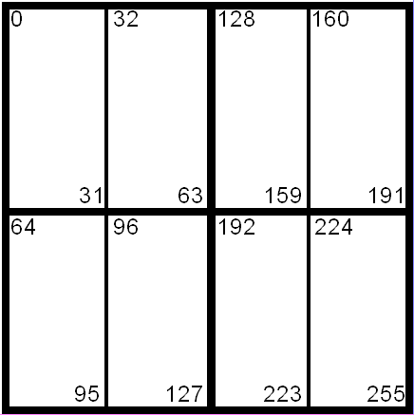Split each individual square and you get eight subnets with 32 addresses,

/27 255.255.255.224
32 Hosts

8 Subnets
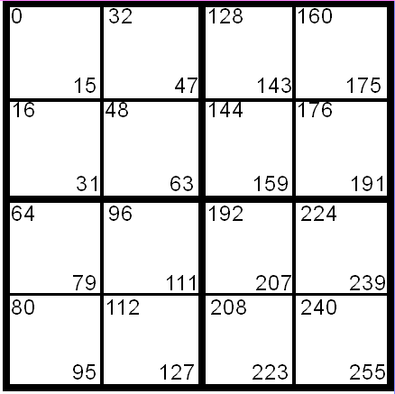Split the boxes in half again and you get sixteen subnets with sixteen
addresses,

/28 255.255.255.240
16 Hosts

16 Subnets

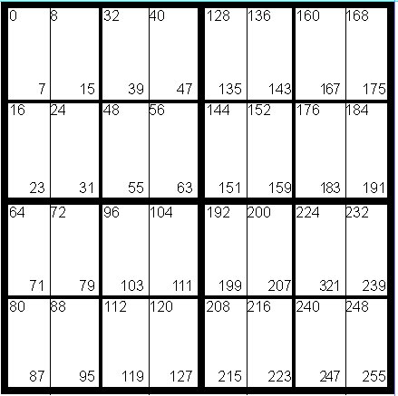The next split gives you thirty two subnets with eight addresses,

/29 255.255.255.248
8 Hosts

32 Subnets
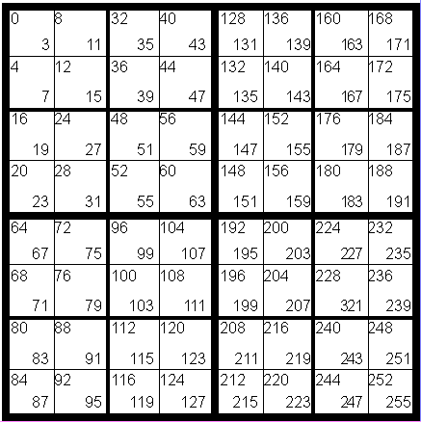The last split gives sixty four subnets with four addresses each,

/30 255.255.255.252
4 Hosts

64 Subnets
81

Class A Addressing Guide
CIDR | # of Bits  Borrowed | Subnet  Mask | Total # of  Subnets | Total # of  Hosts | Usable # of  Hosts
/8 | 0 | 255.0.0.0 | 1 | 16,777,216 | 16,777,214
/9 | 1 | 255.128.0.0 | 2 | 8,388,608 | 8,388,606
/10 | 2 | 255.192.0.0 | 4 | 4,194,304 | 4,194,302
/11 | 3 | 255.224.0.0 | 8 | 2,097,152 | 2,097,150
/12 | 4 | 255.240.0.0 | 16 | 1,048,576 | 1,048,574
/13 | 5 | 255.248.0.0 | 32 | 524,288 | 524,286
/14 | 6 | 255.252.0.0 | 64 | 262,144 | 262,142
/15 | 7 | 255.254.0.0 | 128 | 131,072 | 131,070
/16 | 8 | 255.255.0.0 | 256 | 65,536 | 65,534
/17 | 9 | 255.255.128.0 | 512 | 32,768 | 32,766
/18 | 10 | 255.255.192.0 | 1,024 | 16,384 | 16,382
/19 | 11 | 255.255.224.0 | 2,048 | 8,192 | 8,190
/20 | 12 | 255.255.240.0 | 4,096 | 4,096 | 4,094
/21 | 13 | 255.255.248.0 | 8,192 | 2,048 | 2,046
/22 | 14 | 255.255.252.0 | 16,384 | 1,024 | 1,022
/23 | 15 | 255.255.254.0 | 32,768 | 512 | 510
/24 | 16 | 255.255.255.0 | 65,536 | 256 | 254
/25 | 17 | 255.255.255.128 | 131,072 | 128 | 126
/26 | 18 | 255.255.255.192 | 262,144 | 64 | 62
/27 | 19 | 255.255.255.224 | 524,288 | 32 | 30
/28 | 20 | 255.255.255.240 | 1,048,576 | 16 | 14
/29 | 21 | 255.255.255.248 | 2,097,152 | 8 | 6
/30 | 22 | 255.255.255.252 | 4,194,304 | 4 | 2

Class B Addressing Guide
CIDR | # of Bits  Borrowed | Subnet  Mask | Total # of  Subnets | Total # of  Hosts | Usable # of  Hosts
/16 | 0 | 255.255.0.0 | 1 | 65,536 | 65,534
/17 | 1 | 255.255.128.0 | 2 | 32,768 | 32,766
/18 | 2 | 255.255.192.0 | 4 | 16,384 | 16,382
/19 | 3 | 255.255.224.0 | 8 | 8,192 | 8,190
/20 | 4 | 255.255.240.0 | 16 | 4,096 | 4,094
/21 | 5 | 255.255.248.0 | 32 | 2,048 | 2,046
/22 | 6 | 255.255.252.0 | 64 | 1,024 | 1,022
/23 | 7 | 255.255.254.0 | 128 | 512 | 510
/24 | 8 | 255.255.255.0 | 256 | 256 | 254
/25 | 9 | 255.255.255.128 | 512 | 128 | 126
/26 | 10 | 255.255.255.192 | 1,024 | 64 | 62
/27 | 11 | 255.255.255.224 | 2,048 | 32 | 30
/28 | 12 | 255.255.255.240 | 4,096 | 16 | 14
/29 | 13 | 255.255.255.248 | 8,192 | 8 | 6
/30 | 14 | 255.255.255.252 | 16,384 | 4 | 2

Class C Addressing Guide
CIDR | # of Bits Borrowed | Subnet Mask | Total # of Subnets | Total # of Hosts | Usable # of Hosts
/24 | 0 | 255.255.255.0 | 1 | 256 | 254
/25 | 1 | 255.255.255.128 | 2 | 128 | 126
/26 | 2 | 255.255.255.192 | 4 | 64 | 62
/27 | 3 | 255.255.255.224 | 8 | 32 | 30
/28 | 4 | 255.255.255.240 | 16 | 16 | 14
/29 | 5 | 255.255.255.248 | 32 | 8 | 6
/30 | 6 | 255.255.255.252 | 64 | 4 | 2

82

Inside Cover

